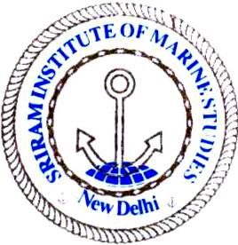 | Sriram Institute of Marine Studies  Approved by the DG Shipping, Ministry of Shipping, Govt. of India. Affiliated to Indian Maritime University Chennai, Certified ISO 9001:2015 By Indian Register of Shipping {IRS} MTI Unique id : 101005

Staff Minute Sheet
Originator Department :
To :
Originator Department
To
Course officer/coordinator
Subject:

This is submitted that the above department has been involving in imparting education and training to the student of ______________ course. The following requirement has / will be occurred for smooth conduct of the coming courses. The requirement is as under:

SNo | Description/Item | Quantity Reqd. | Type of store | Be issued by

Date : _____________________ ____________________________
Place _____________________ Signature of applicant with date
Name____________________ ______

Recommendation by the course in charge/Coordinator __________________________________________________________________________

Date : _____________________ ____________________________
Place _____________________ Name &Signature of course /Dept
coordinator with date

Approved by : HOI/ ED with date and signature

Distribution : 1st copy _ Store in charge
2nd copy- Office copy

