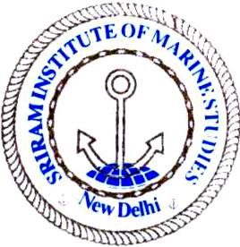 | Sriram Institute of Marine Studies  Approved by the DG Shipping, Ministry of Shipping, Govt. of India. Affiliated to Indian Maritime University Chennai, Certified ISO 9001:2015 By Indian Register of Shipping {IRS} MTI Unique id : 101005

Page Sl No |  | Name of equip |  | Pmt/Qusi/Consm.

Item Sl No | Department | Department | Location | In charge

Class/Group/patt | present stock | date of last stock mustered | Signature of custodian

Date | Item pattern No if any | Previous stock | Quantity procured | Date | Total | Sign & date custodian

