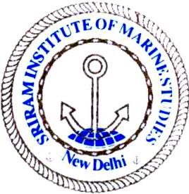 | Sriram Institute of Marine Studies  Approved by the DG Shipping, Ministry of Shipping, Govt. of India. Affiliated to Indian Maritime University Chennai, Certified ISO 9001:2015 By Indian Register of Shipping {IRS} MTI Unique id : 101005 | ISO/QMS Clause No 8.1
Ref QMS 8.0  Page : 01 | Subject: Holiday on 26.01.2023 | File No IMS/ADM/16
Issued by : Exe. Director | SIMS Circular No 03 of 2022 | Date: 24.01.2023

The institute shall remain closed on 26.01.2023, Thursday on account of Republic Day of India. No any classes shall be conducted on 26.01.2023. Normal daily/Modified routine shall be observed on 27.01.2023, Friday on account of 20th Anniversary of this institute. Firm programme shall be promulgated soon.

This is for your strict compliances

Joginder Singh
Executive Director

Distribution: Normal

Chairman/HOI Sir for info please
Main Notice Board
Faculty and Instructor- Via IMS Portal
Students – IMS Portal

